b

NAT NATIONAL UNIVERSITY OF COMPUTER AND EMERGING SCIENCES

(KARACHI CAMPUS)

School of Computing

**ASSIGNMENT NO 02**

|  |
| --- |
| **Subject: Programming Fundamentals -CS1002-FALL2022 Date: 9/10/2022**  **Total Marks: 60 Due Date: 20/10/2022, 04:00 pm**  **Course Instructor: Shahbaz Siddiqui** |

**Instructions to be strictly followed.**

* Carefully read the questions and understand the depth.
* Strictly submit in due time.
* Late submission with penalty.
* Submit in only Google Class , no other submission will considered .
* Mark Distribution

**Submit on time =10**

**Solve maximum Question=30**

**Assessment through Quiz=20**

**Question # 1: (10-Points)**

A smart city which is equipped with the latest technologies such as self-driving cars (SD), robots, UAV, and many others is shown in Fig.1. Consider a UAV which is deployed to monitor the agriculture field and communicate with the robot, which can take an ***N*** number of different locations (**A, B**, **C, and N)** (refer Fig.1).

Develop a C-script that calculates the distance between reference point **R (1,3)** of a **UAV** and robot locations **A**, **B**, **C,** and ***N*** number of locations.

***N*** is the (**non- zero)** LSD of your mobile number.

For 0 **< LSD < 4** then take **[N = (2LSD) *2]**, and if LSD **= 0**, take **[ N = (2LSD) *4+3]**

***Note:*** (Use **For loop and While** **Loop** to accomplish this task).

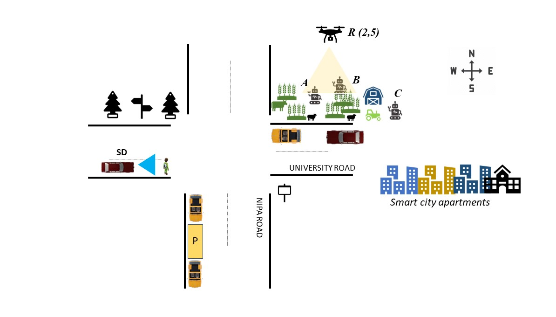

**Fig.1** A smart city depiction

**Question # 2: (10-Points)**

***Covid’19*** vaccination has become a mandatory requirement for many things such as traveling, bank account opening, admissions in higher educational universities, and many more. Develop a C- script that facilitates the hospital in determining which person needs to be vaccinated based on age and underlying disease. The program should run for ***N*** persons and perform the followings: (N should be taken as a user input).

1. if age is greater than or equal to 18 and person belongs to the Urban area of a city then program should display the following message:

***Eligible for the vaccine. Kindly proceed for the vaccination***

1. if age is less than 18 and person to the Rural area of a city then program should display the following message

***Not Eligible for the vaccine. Kindly wait for the vaccination***

1. Also list the possibilities in how many ways we can solve the problem given in **Question no 02**.

**Question # 3: (10-Points)**

Alice and Bob want to exchange the n- digits message on the internet, but they want to ensure the security. They went to a cyber security specialist Edwin for the solution. Edwin listened to the requirement of the clients and proposed a scheme for cryptography, which is mentioned in following points

1. The algorithm would reverse the message
2. After reverting the message, it would determine an alphabetic character against the digit. For example, for 0 it would be A, for 1 it would be B, for 2 it would be C, for Z it would be 25.

Write a code in C for the above cryptographic algorithm using loops in C for Edwin.

The samples are like:

|  |  |
| --- | --- |
| **Input String** | **Cypher Text** |
| 1546 | GEFB |
| 7777 | HHHH |
| 5555 | FFFF |
| 1234 | EDCB |

1. Also provide the solution for decryption the message. (System should ask user for encryption and decryption at the start of the program)

**Question # 4: (10-Points)**

A robotics and technological center offer various training and workshop sessions to the registered members. The robotics center has implemented chatbot at the main entrance for checking the membership status of the people. The chatbot is incorporated with the AI- enabling logics to check the membership status. The chatbot system displays 4-digit message randomly on the screen and after reading the message user would type the output.

**The main process would be:**

User would read the message from screen and would add (1 if he is male and, 0 if she is female) Furthermore, he/she would add age to the input. After this the user would add all the digits of the input and finally take remainder with 5 of the output.

This process would be like this:

|  |
| --- |
| **Case 1: The age of the user is 40, and he is male.** |
| Input string is: 3231, he would add 41 to the string then it would become 3272. Then he would add individual digits of the string 3+2+7+2 which would generate 18, finally 18%5 is 3 so the answer would be 3. |
| **Case 2: The age of the user is 15, and he is female.** |
| Input string is: 1000, he would add 15 to the string then it would become 1015. Then he would add individual digits of the string 1+0+1+5 which would generate 7, finally 7%5 is 2 so the answer would be 3. |

Your task is to write a C program using nested decision structures program for chatbot automatic verification of the password. At this level you need to provide the input and output of the code and match the results.

|  |
| --- |
| **Input a 4-digit number**  The user entered 1000(the computer generates the random string but in this case you can take input from user)  **Input your age and gender**  The user entered 15 and 0  **Input the verification code**  The user inputs 2  The system says correct, if the user enters other digit, the system would say incorrect |

**Question # 5: (10-Points)**

Write a program for an ice-cream manufacturing company. Assuming that 50 ice-creams can be prepared each hour whereas each Ice-cream costs 60Rs. The plant operates 8hrs per day but can have operating ability of 16hrs per day. But for another 8-hrs, the cost of each ice-cream would be doubled. You have to implement a method that identifies whether you want the plant to run 8hrs or 16 hrs. per day. Each ice-cream’s cost is fixed. You have to calculate how many days and hours it will take to produce any number of ice-creams and what would be the cost. Write a program that asks the user for the number of ice-creams that have been ordered and also whether the person required the plant to run 16hrs or 8 hrs. per day and then displays the bill for the customer that indicate the number of days and hours it will take to produce them and also the total cost of ice-creams along with their cost distribution based on plant-running time.

**Question # 6: (10-Points)**

An unarmed vehicle**(UAV)** is operating in a **smart environment** where it is communicating with a mobile device and a self-driving car (refer Fig.2 Drone Alpha). The UAV is equipped with an AI facility, and it displays the pattern A when it communicates with the SD. On the other hand, it shows pattern B when it starts communication with the mobile device. Develop a C-script that is needed to be integrated into UAV, which generates pattern A (refer fig.2) for SD car and pattern B (refer fig.2) for mobile device.

Input: Iterations

**s = communicating with SD**

**m = communicating with mobile**

Output: **Pattern A when communicating with SD**

**Pattern B when communicating with mobile device**

*Pattern B*

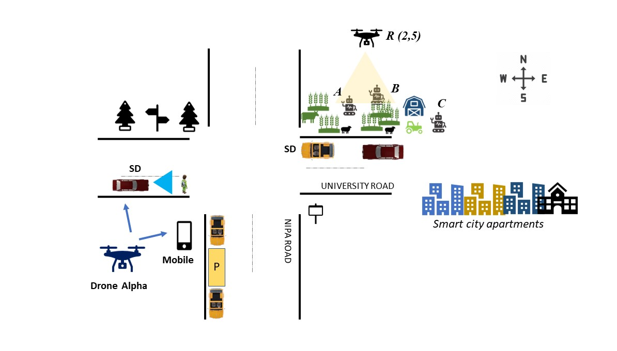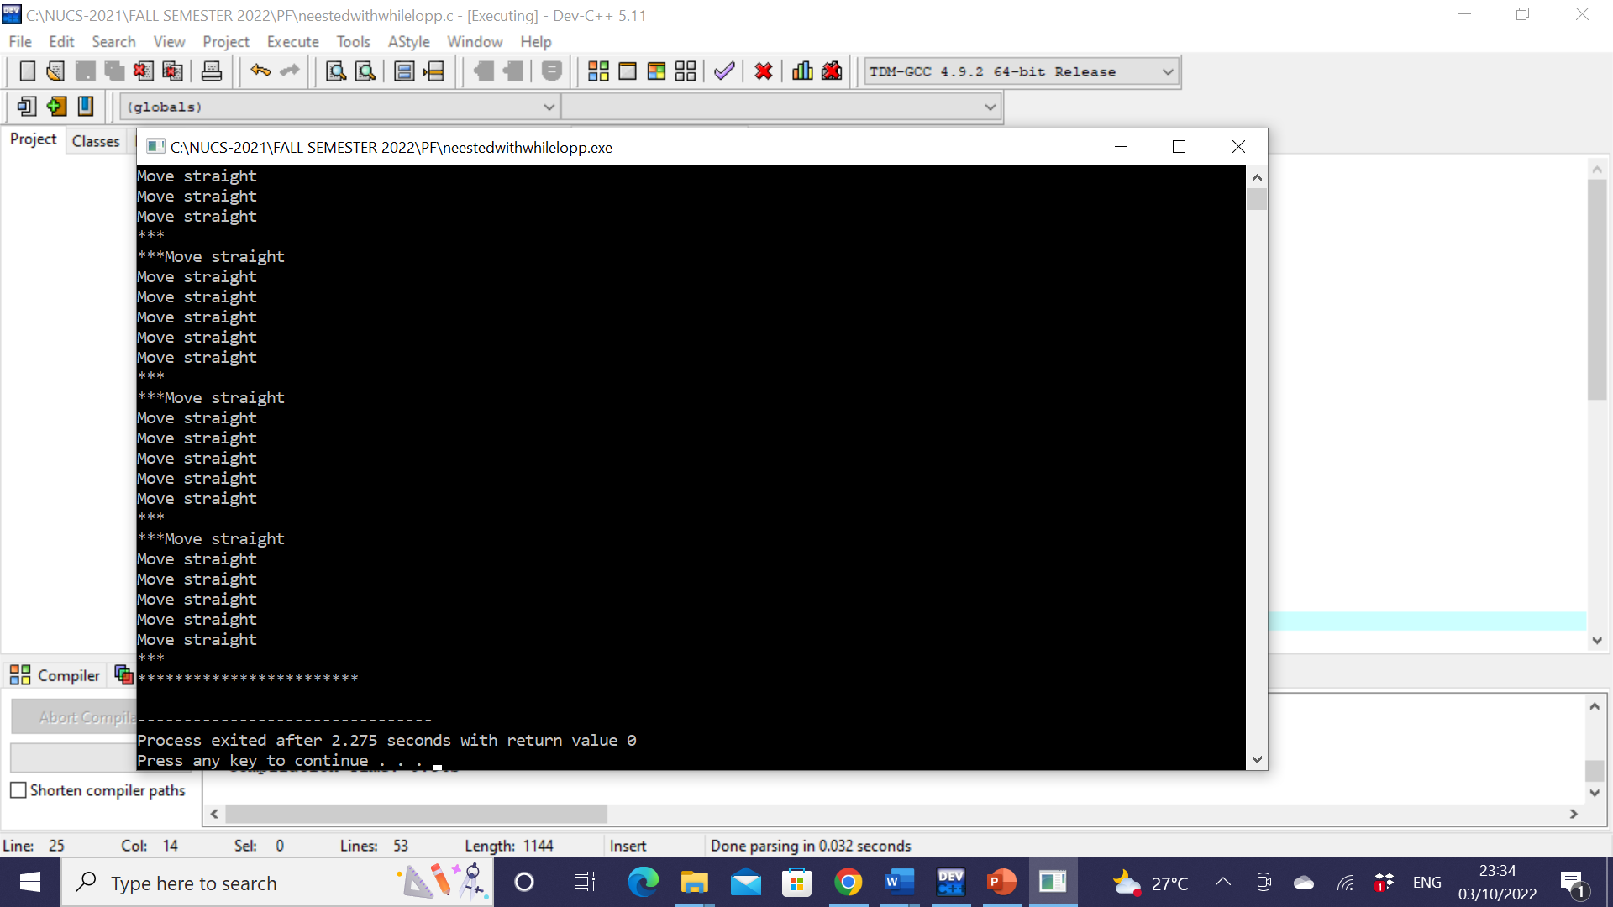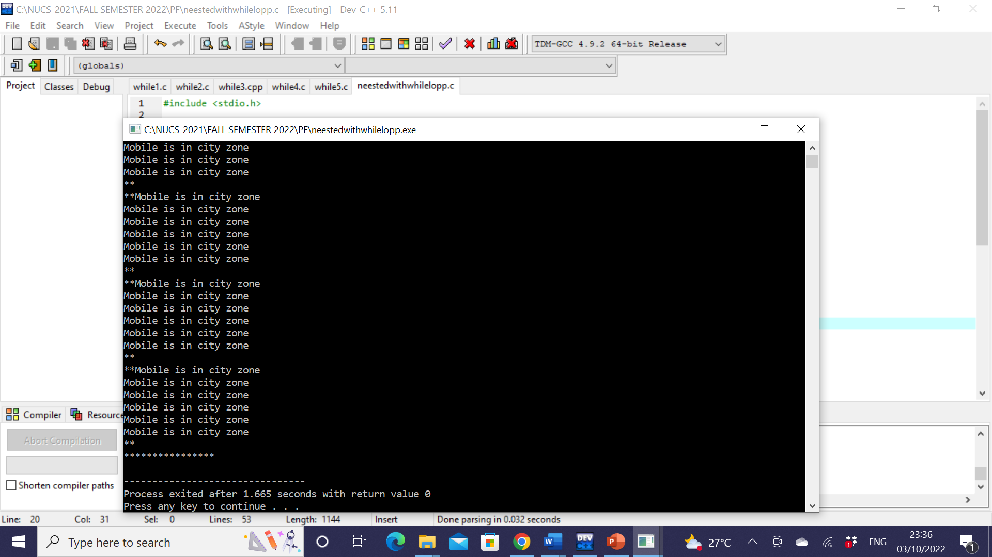

*Pattern A*

**Fig.2** Smart city network in which UAV, SD and mobile device are communicating